CUSTOMER CHURN PREDICTION IN TELECOM INDUSTRY
(Machine Learning Based Customer Retention System)
Block Diagrams (all)
Department of Computer Science and Engineering, TKR College of Engineering and Technology (Autonomous)
Batch A14 (CSE-A) · Academic year [ACADEMIC YEAR]
Table 1: Project team
S.No. | Student name | Roll number
1 | ANANTULA SAI NIKHILA SRAVANI | 23K91A0512
2 | AVULA ANUDEEP | 23K91A0518
3 | B SANDEEP | 24K915A0503
4 | DARAGANI VINOD KUMAR | 23K91A0558

Project guide: B. SRIKANTH, Assistant Professor, Department of CSE
Chapter and section numbers quoted in the text (for example Section 6.6 or Chapter 8) refer to the full project report, 17.Final Document. Figures and tables in this document are numbered from 1.

1. INDEX OF DIAGRAMS
Every diagram is generated from the real design by scripts/make_diagrams.py (matplotlib, 150 dpi) and mirrors the code in src/, backend/ and app.py. There is no SQL database, so the entity-relationship diagram shows the logical data model.
Table 2: Diagrams in this document
No. | Diagram | Image file
1 | System architecture | docs/diagrams/01_system_architecture.png
2 | High-level workflow | docs/diagrams/02_high_level_workflow.png
3 | Data flow diagram, level 0 | docs/diagrams/03_dfd_level0.png
4 | Data flow diagram, level 1 | docs/diagrams/04_dfd_level1.png
5 | Data flow diagram, level 2 | docs/diagrams/05_dfd_level2.png
6 | UML class diagram | docs/diagrams/06_uml_class_diagram.png
7 | Sequence diagram | docs/diagrams/07_sequence_diagram.png
8 | Use-case diagram | docs/diagrams/08_use_case_diagram.png
9 | Entity-relationship diagram | docs/diagrams/09_er_diagram.png
10 | Core algorithm flowchart | docs/diagrams/10_core_algorithm_flowchart.png

2. DIAGRAMS

System architecture
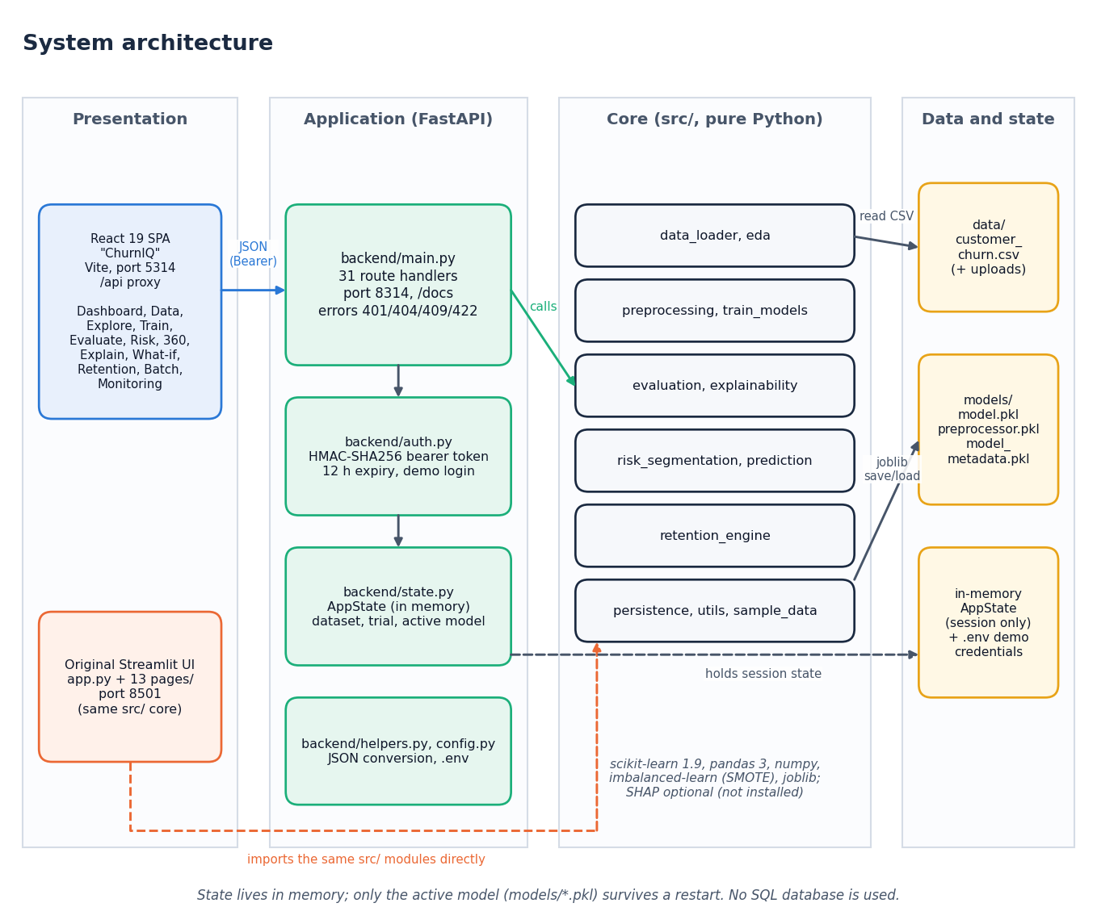
Figure 1: System architecture of ChurnIQ
The system has four layers. The presentation layer is the React interface (port 5314, which proxies /api to the API) and the original Streamlit interface (port 8501). The application layer is the FastAPI service in backend/ with 31 route handlers, bearer-token authentication and an in-memory AppState. The core layer is the pure-Python package src/, which both interfaces call and which contains no interface code. The data layer is the CSV file, the three joblib files of the saved model and the in-memory state. There is no SQL database.

High-level workflow
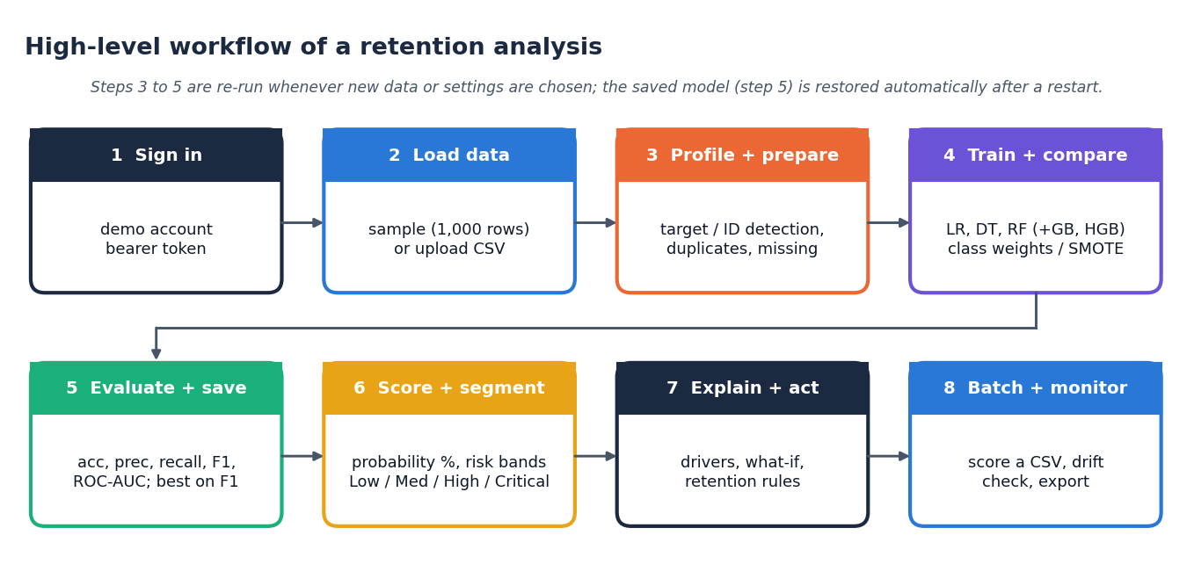
Figure 2: High-level workflow of a retention analysis
Eight steps from signing in to batch scoring and monitoring. Steps 3 to 5 are repeated whenever new data or settings are chosen; the saved model of step 5 is restored automatically after a restart.

Data flow diagram, level 0
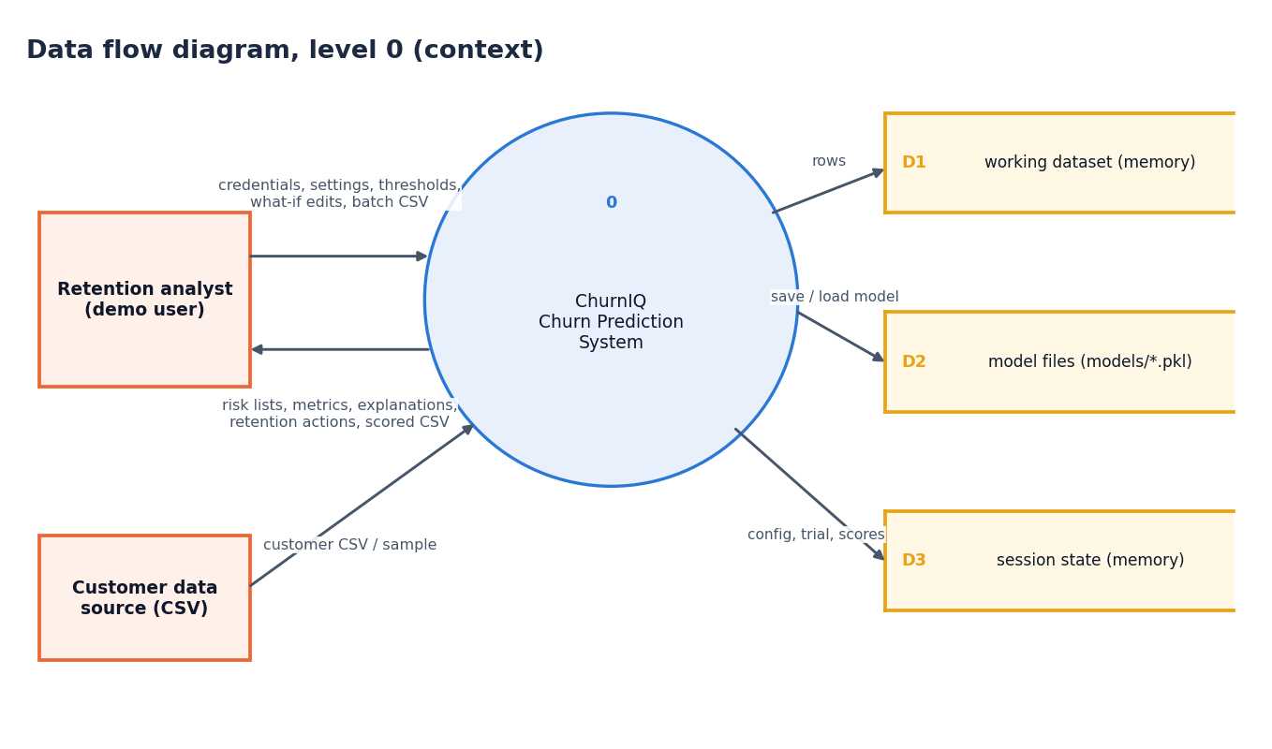
Figure 3: Data flow diagram, level 0 (context)
One process, the ChurnIQ system, exchanges data with the analyst and with the customer data source and uses three stores: the working dataset and session state, which are in memory, and the model files on disk.

Data flow diagram, level 1
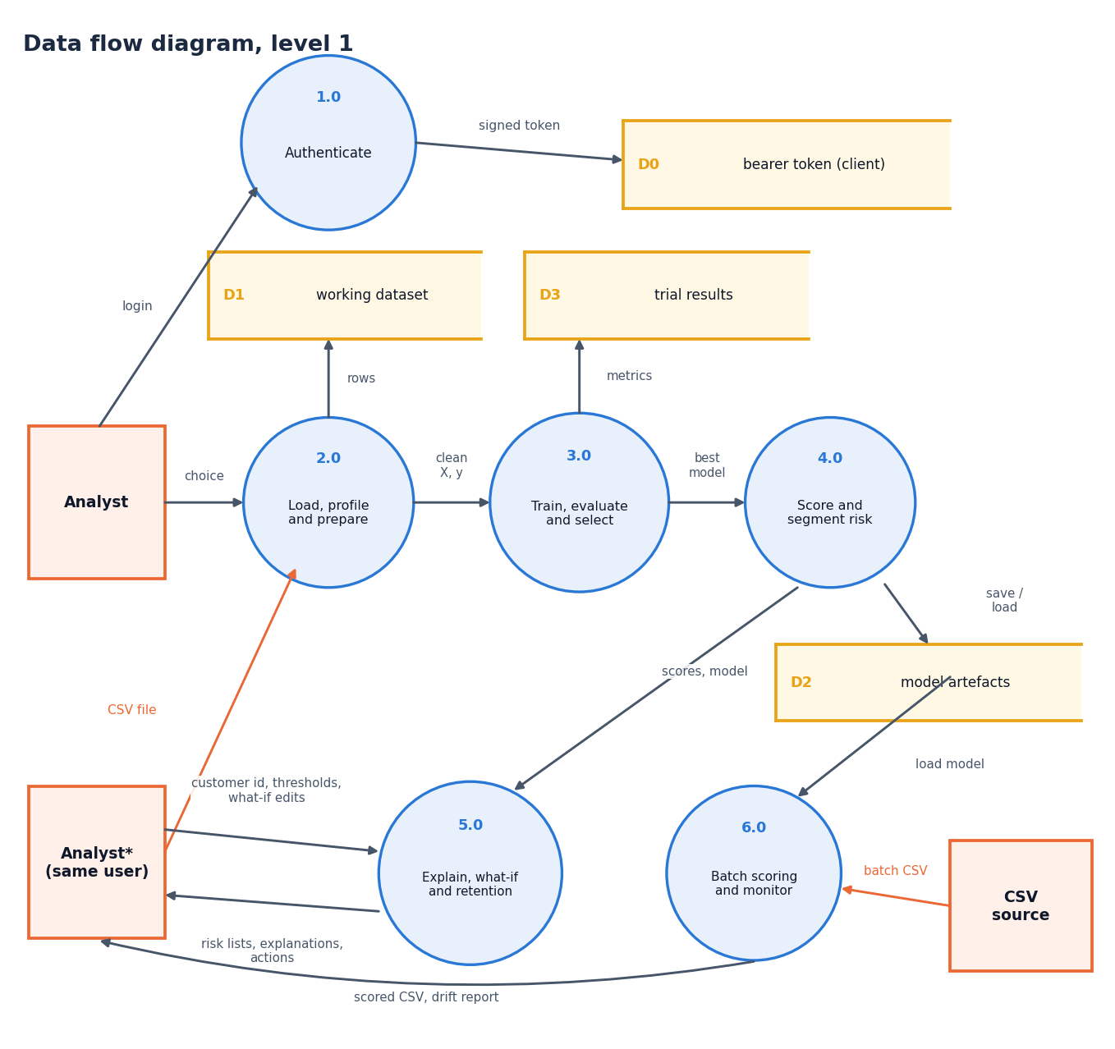
Figure 4: Data flow diagram, level 1
Six processes: authenticate (1.0), load, profile and prepare (2.0), train, evaluate and select (3.0), score and segment risk (4.0), explain, what-if and retention (5.0) and batch scoring and monitoring (6.0). The model artefacts written by 3.0 and read by 4.0 and 6.0 are the link between training and use.

Data flow diagram, level 2
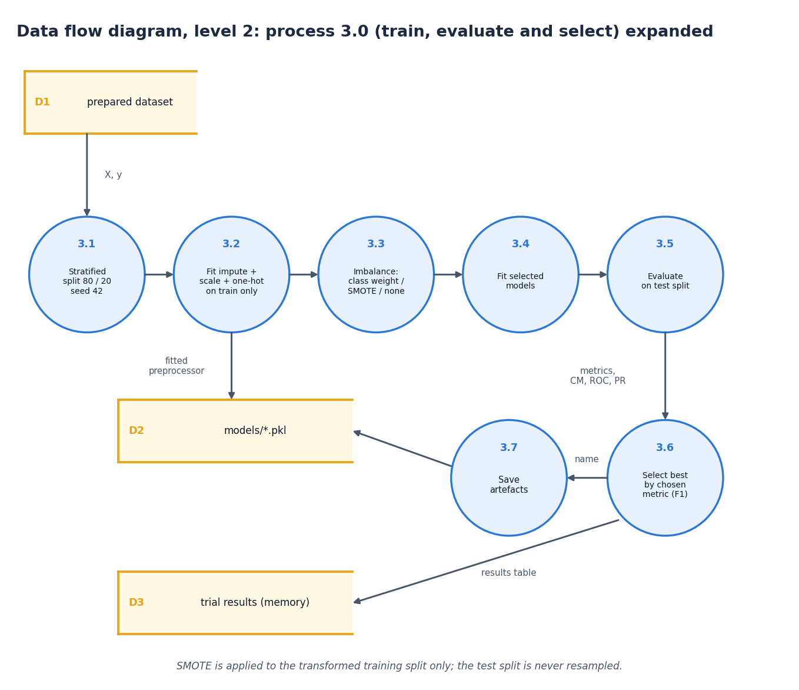
Figure 5: Data flow diagram, level 2: train, evaluate and select
Process 3.0 expanded into seven sub-processes: stratified split, preprocessor fit on the training split only, imbalance handling, model fitting, evaluation on the test split, selection of the best model and saving of the artefacts. SMOTE touches only the training split.

UML class diagram
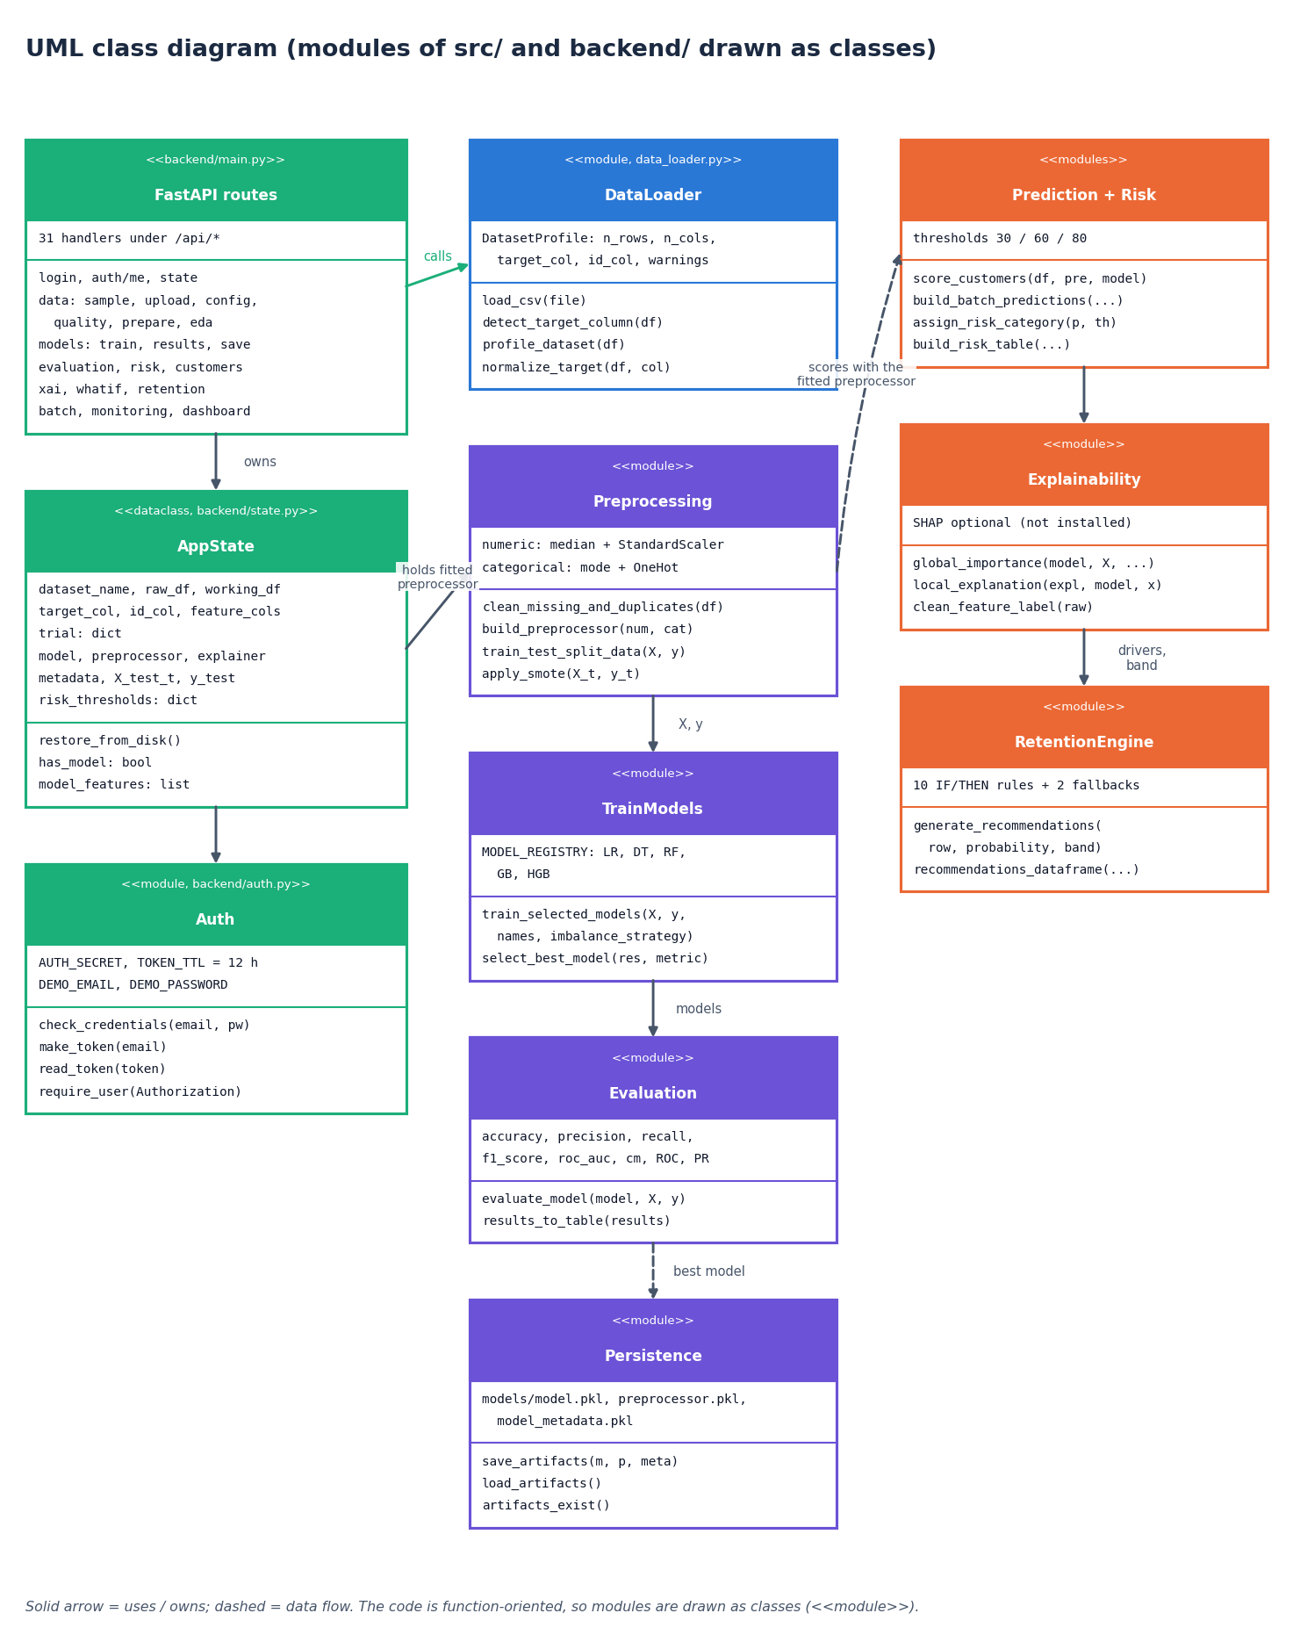
Figure 6: UML class diagram (modules drawn as classes)
The code base is function-oriented, so the diagram draws each module of src/ and backend/ as a class with the data it holds and the operations it offers. AppState is the only real class (a dataclass) and owns the dataset, the trial results, the active model and the risk thresholds. Arrows show which module uses which.

Sequence diagram
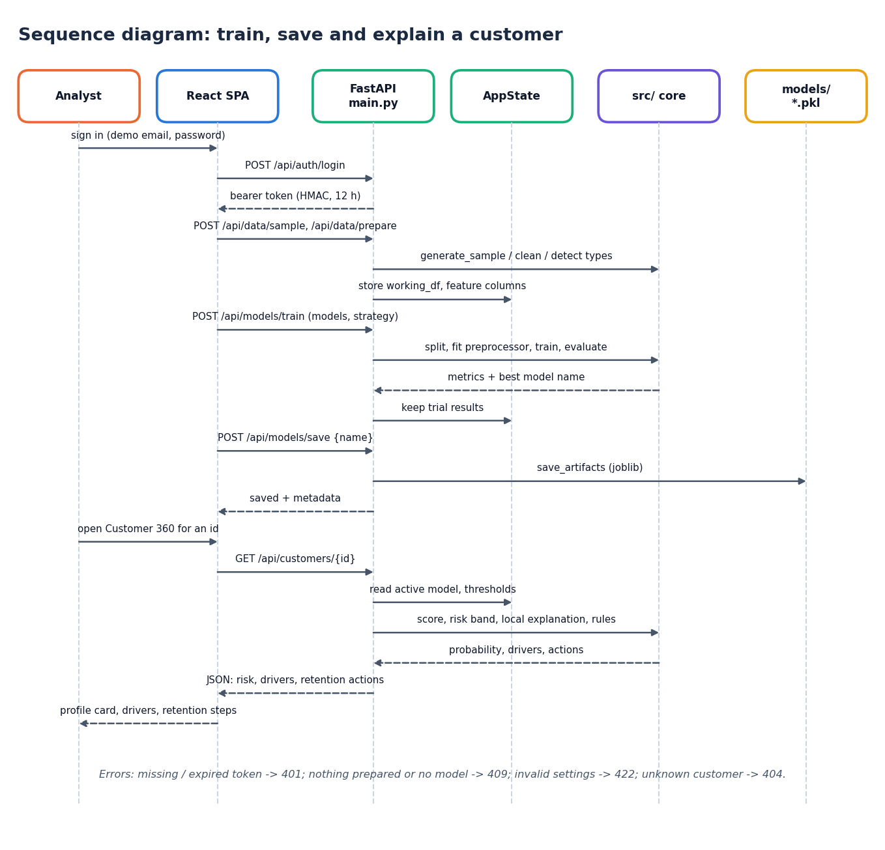
Figure 7: Sequence diagram: sign in, train, save and open Customer 360
The messages exchanged when an analyst signs in, loads and prepares the sample, trains and saves a model and then opens one customer. The API validates the token on every call after the login and returns the error codes listed at the foot of the figure.

Use-case diagram
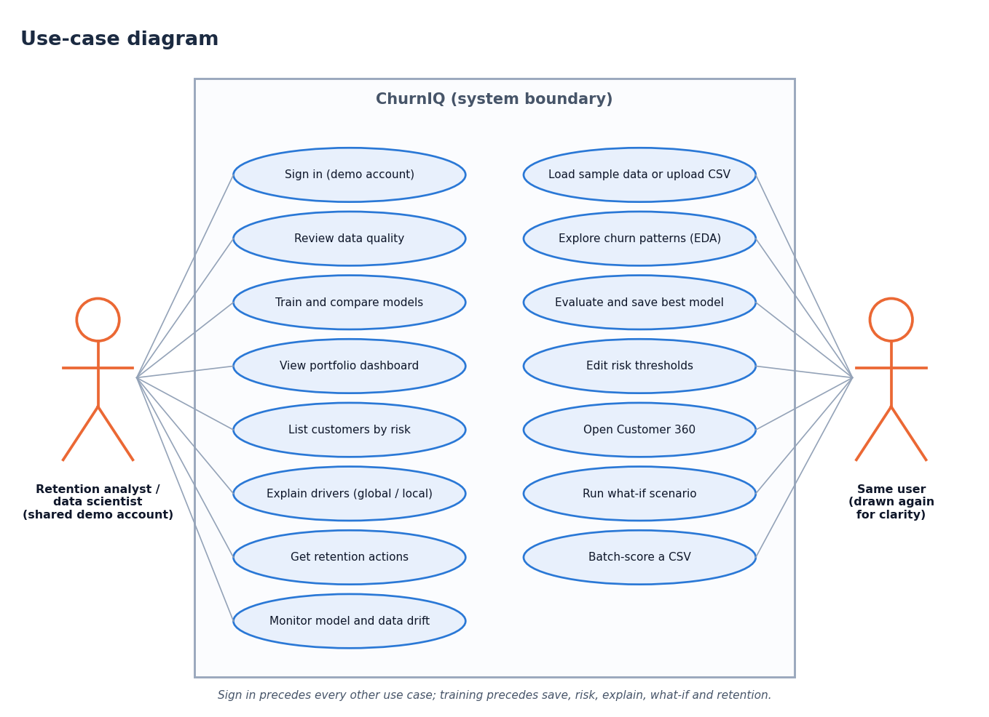
Figure 8: Use-case diagram
One actor, the retention analyst (who also trains models), and fifteen use cases. The actor is drawn twice only to keep the lines from crossing.

Entity-relationship diagram
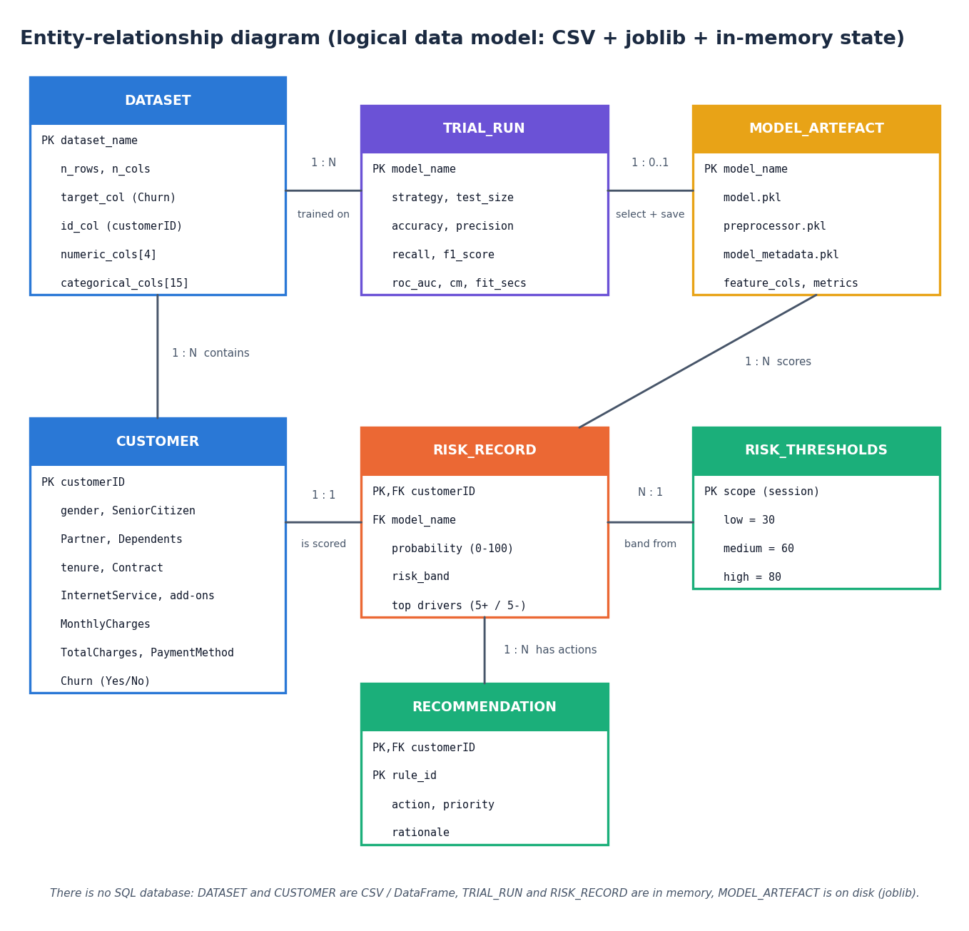
Figure 9: Entity-relationship diagram (logical data model)
The project has no database, so this is the logical data model of the entities the code handles: the dataset and its customers, the trial runs, the saved model artefact, the risk record of each customer, the thresholds and the recommendations. Relationships and keys are those of the in-memory tables and the files on disk.

Core algorithm flowchart
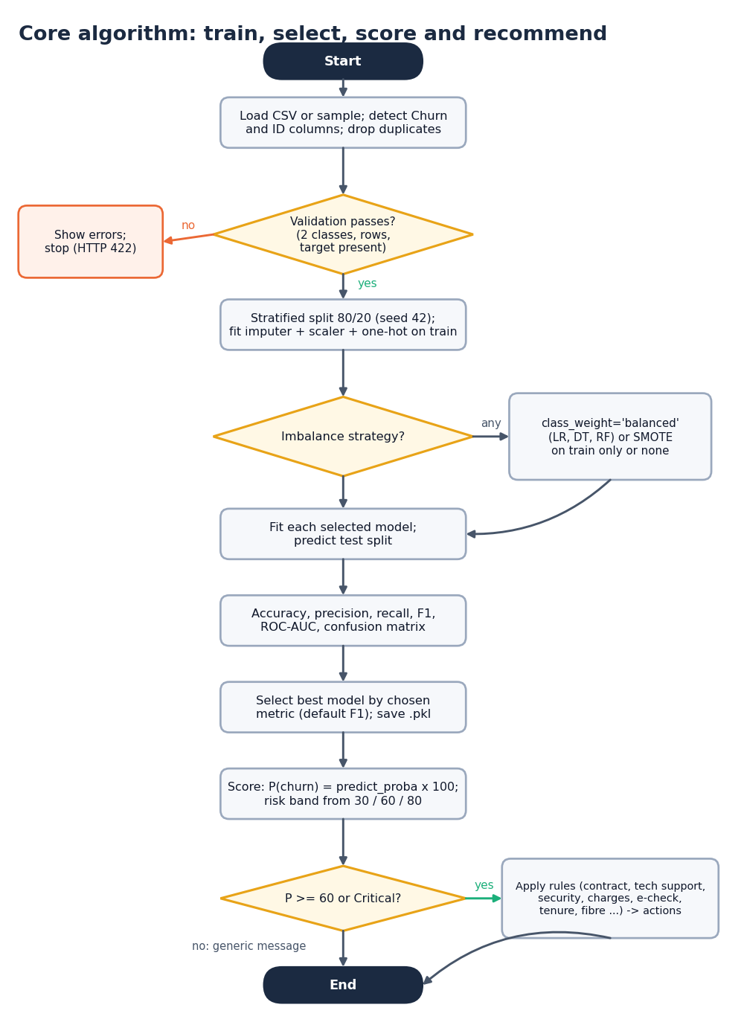
Figure 10: Flowchart of the core algorithm: train, select, score and recommend
The decisions of the pipeline: validate the data, choose the imbalance strategy, fit and evaluate the models, select and save the best, score customers, and apply the retention rules to customers at or above 60%.

